**Siphokazi Maloyi- CG/24/0039- 002**

**Introduction**

The Dynamic Host Configuration Protocol (DHCP) is a critical network service that automatically assigns IP addresses to devices on a network. A DHCP pool defines the range of available IP addresses that the server can lease to clients. In a large-scale wireless network environment, the size of the DHCP address pool can have significant implications for network performance. A small address pool may lead to address exhaustion during peak usage times, causing connectivity issues and network downtime. On the other hand, a large address pool with inefficient resource allocation can result in wasted IP addresses and increased DHCP server load (Wang et al., 2018). This assignment will analyse how the size of the DHCP pool can impact network performance and this will simulated using Cisco Packet Tracer.

**The Simulation:**

First, a basic network topology is set up, consisting of a DHCP server, a router, a switch, and multiple end devices such as PCs. The DHCP server is configured with a specific IP address range for its DHCP pool, and the router is set up to act as the default gateway for the network. The network setup allows for controlled variation in the number of clients requesting IP addresses from the DHCP server. As shown below:

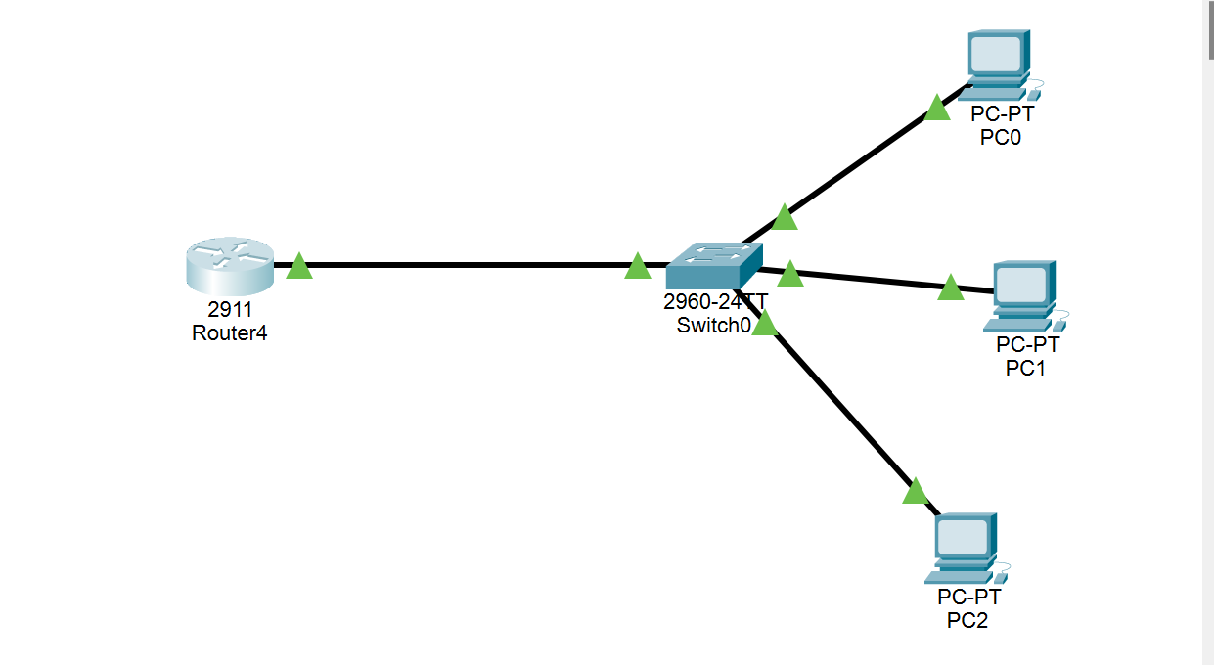

Once the network is established, the experiment begins by varying the size of the DHCP pool to observe how it affects the lease acquisition time for clients. With a smaller pool, the experiment simulates scenarios where there are more clients than available IP addresses, potentially leading to conflicts and delays in obtaining a lease. As the pool size increases, the expected outcome is faster lease acquisition, reflecting greater availability of IP addresses. More devices added to the pool as shown below:

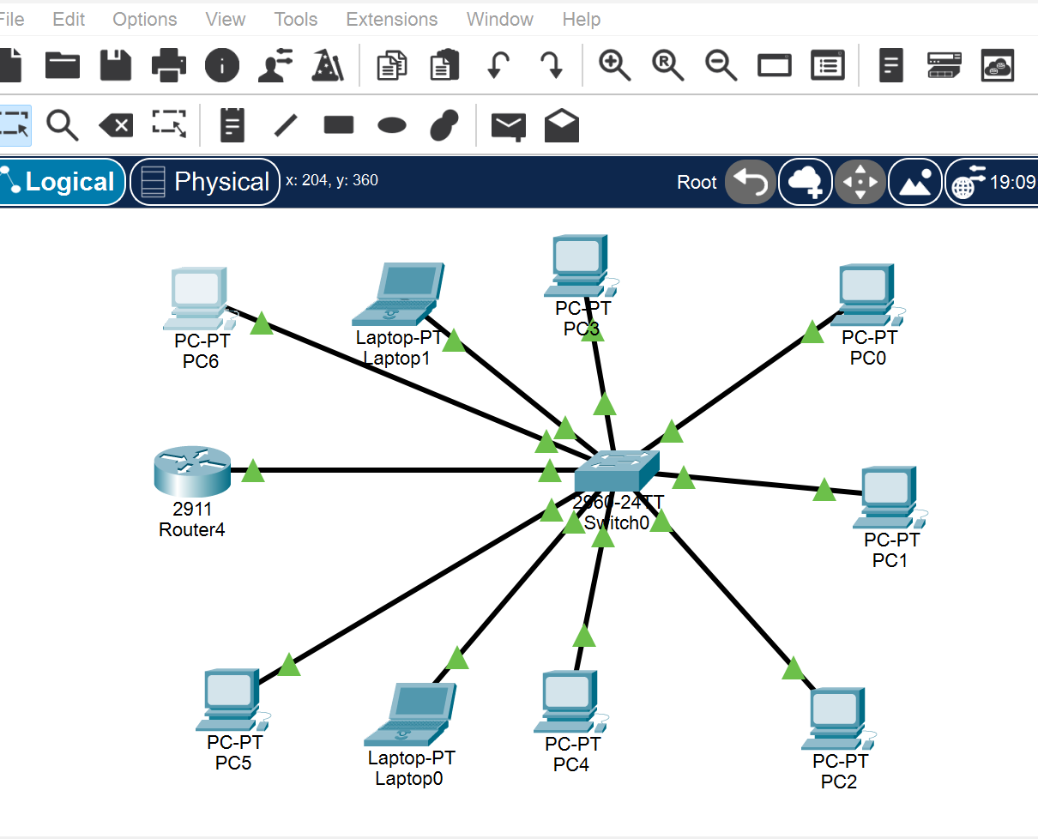

To assess network performance, the `ping` command is used to test connectivity between various devices. By pinging from one device to another, the latency and potential packet loss are measured, providing additional insights into network stability and reliability. Observations are recorded, including the time it takes for clients to acquire IP addresses, any conflicts or errors due to a constrained DHCP pool, and the response times for pings between devices. Command results below PC1 (small pool) vs. PC6 (large pool)

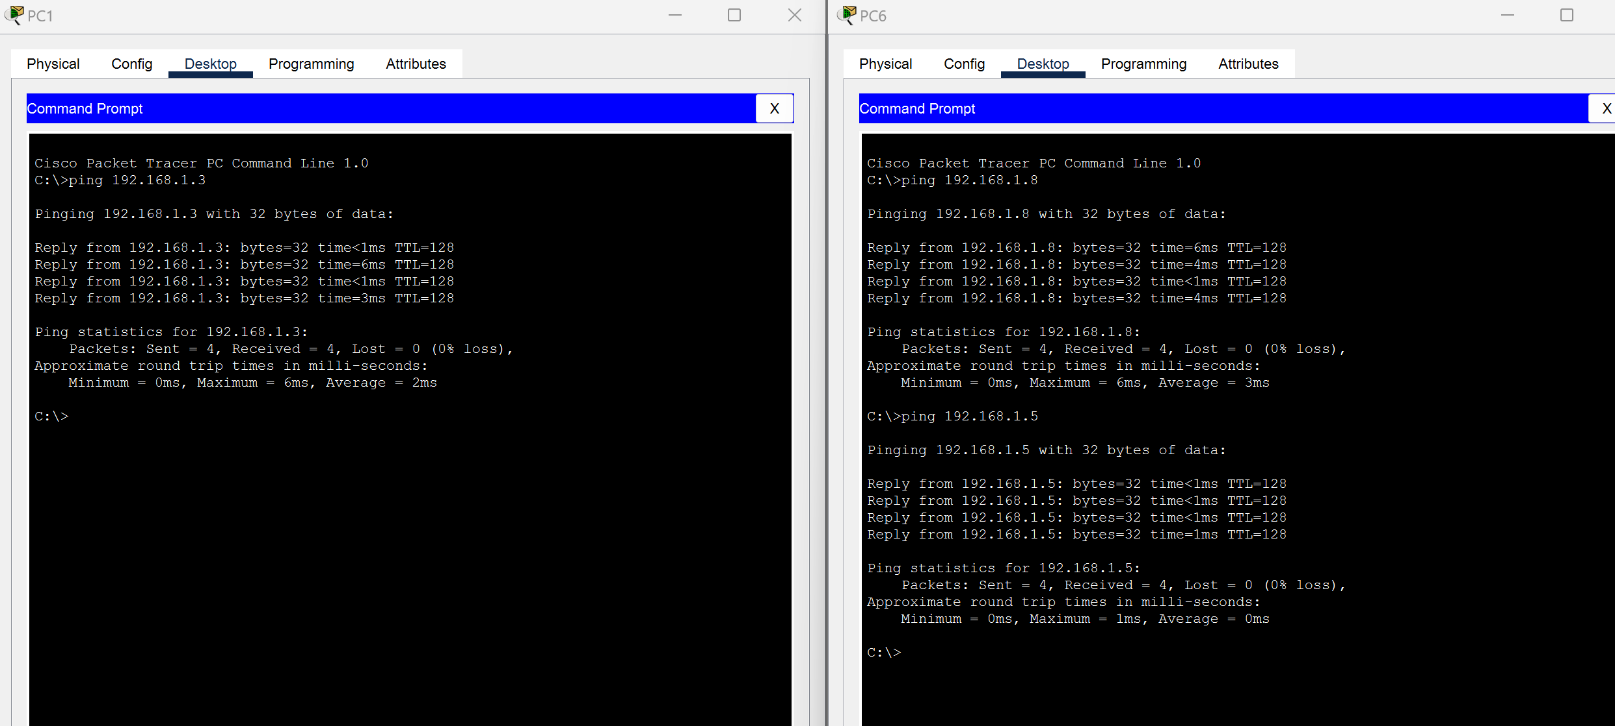

**Analysis of the Packet Tracer Simulations**

The simulation successfully demonstrated the impact of DHCP pool size on network functionality. The results from the ping tests on a Packet Tracer simulation indicate differences in network performance between small and large DHCP pool configurations. For the smaller pool, which has fewer IP addresses available, the observed ping response times are slightly longer, with some variability in latency. Specifically, in the smaller pool, the response times for ping requests to `192.168.1.3` were around 3 to 6 milliseconds, with occasional spikes in latency. This may be due to DHCP-related delays as clients compete for limited IP addresses.

In contrast, with a larger DHCP pool, response times are consistently shorter, and there is less fluctuation in latency. The ping tests to `192.168.1.8` and `192.168.1.5` showed round-trip times between less than 1 millisecond and 6 milliseconds, with minimal variability across multiple pings. Additionally, the ping statistics for the larger pool indicate zero packet loss, suggesting stable network performance.

**Conclusion**

The observations suggest that a larger DHCP pool generally results in faster and more consistent network performance, with reduced ping response times and minimal packet loss. A larger pool allows for smoother DHCP lease acquisition, reducing the chances of IP conflicts or delays in obtaining IP addresses. These factors contribute to a more stable network environment. On the other hand, a smaller DHCP pool can lead to increased competition for IP addresses, potentially causing delays in lease assignment and resulting in slightly increased latency in network operations. These findings highlight the importance of configuring DHCP pools to match the expected network load to maintain optimal network performance.

**Reference:**

Wang, H., Wang, J., Dang, W., Xue, J., & Li, F. (2018). Squeezing the Gap: An Empirical Study on DHCP Performance in a Large-scale Wireless Network